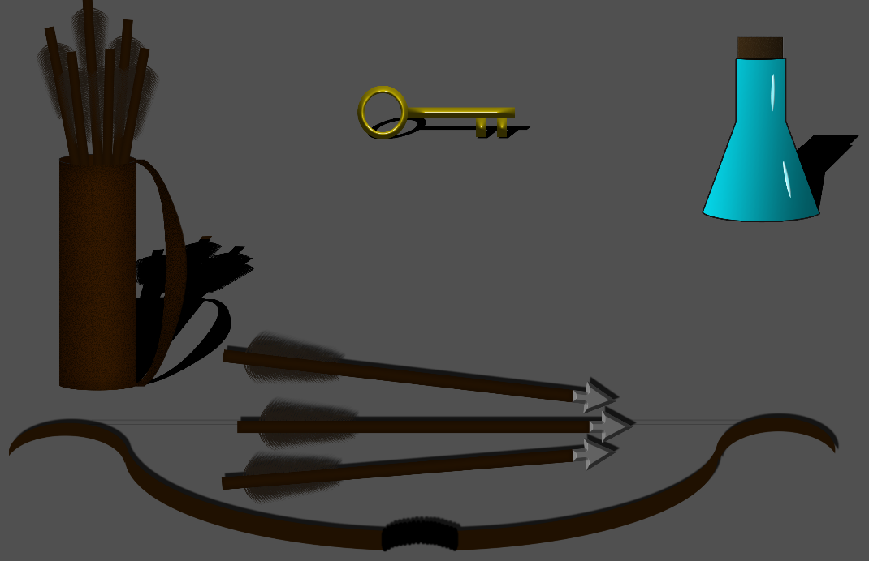

Troll Hunter

Daniel Trayler

GAME 2319

Table of Contents

Backstory pg. 3

Objectives pg. 4

HUD Elements pg. 5

Interactive Elements pg. 6

Walkthrough pg. 7

Win/Lose Condition pg. 8

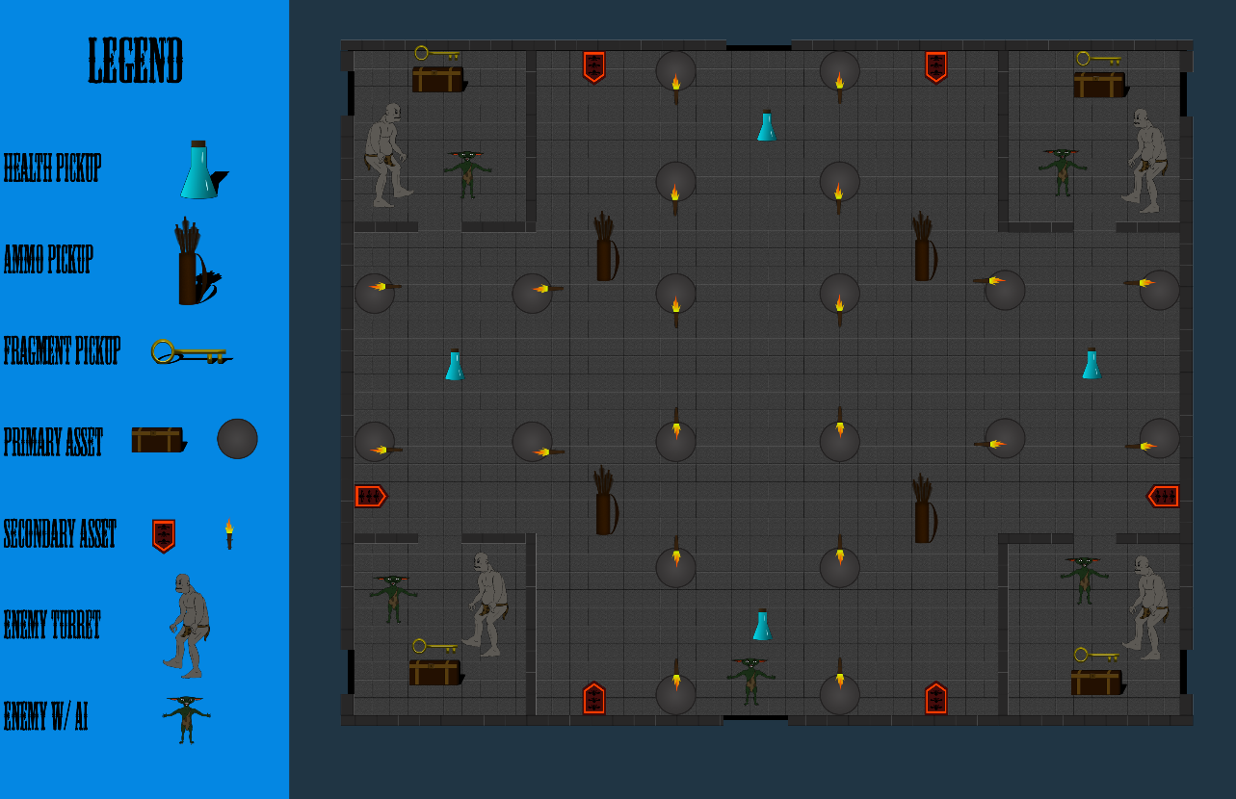

- Backstory – King Arthur has been atop the throne for only a few years now. Among his most faithful followers is his trusted friend and comrade in arms, Lancelot. Together, with the help of the other knights of the round table, they battle evil in many shapes and sizes. Recently, King Arthur's nephew, a young up and comer named Sir Gawain, defeated a mighty dragon that gained him knight-hood and a seat at the round table. This time, however, it is Sir Lancelot who must prove his worth as an honored knight of King Arthur. He has been sent by the King to root out some trolls from an abandoned castle in Milan near the river of Pire. The locals in that vicinity have been rooted from their homes by goblins as well as trolls that roam at night looking for human newborns, their favorite food. There have been 15 newborn deaths since they took shelter in the abandoned castle a year ago. They now have refuge from the daytime when they are most vulnerable. Trolls, their skin is as thick as the iron chains used to hoist a drawbridge so they do not puncture easily, are among the most dangerous beasts in the land. Their weakness can only be found deep in the underground dungeons of Milan in the form of sun-kissed metal. Lancelot will need to find this metal in the shape of arrow tips for his mighty Bow, “The Deliverer”, in order to take down the trolls of Milan.

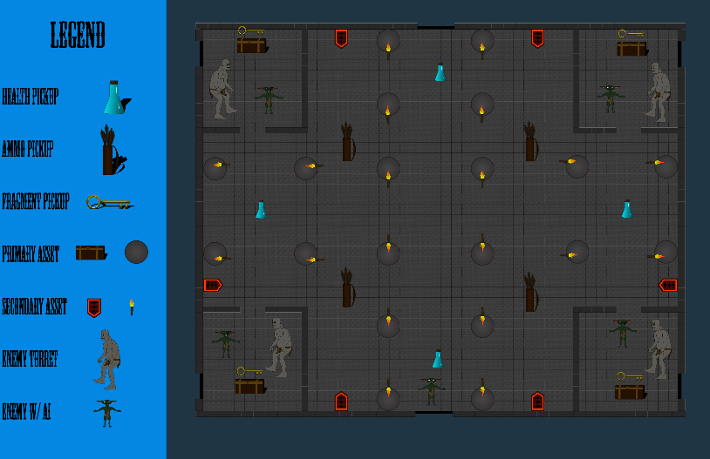

- Objectives - The primary objective of the game is to eradicate the threat of 16 goblins and 6 trolls. This will be accomplished by searching the castle dungeon area you are in for threats. There will be four rooms that require keys to get inside. Each room will have a chest with a key inside as well as at least one troll guarding it. The keys will lead you into the other rooms. The main dungeon room will have one chest in the center of the room. Five goblins will spawn in the back of the room when the player grabs the key from the chest. The front left room will have three goblins and one troll to defeat. The front right room will have three goblins and one troll to defeat. The back left room will have two trolls to defeat. The back right room will have five goblins and two trolls to defeat. After this is done, the player will be able to move onto the next dungeon/Win Condition.

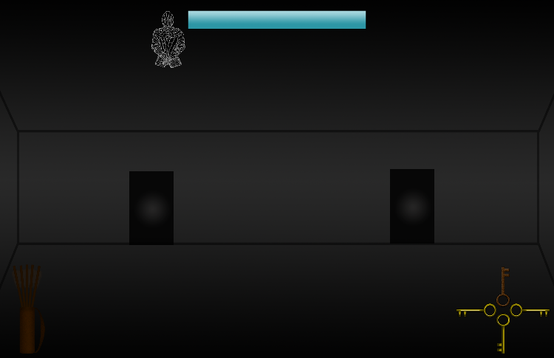

- HUD Elements – The Health Indicator will be a bar with a soldier's metal armor next to it with a blue fill and red bar underneath. The Ammo Indicator will be a brown leather quiver with light brown arrows with silver tips on it. There will be ten arrows at max ammo. An arrow will disappear when the player shoots an arrow. The Inventory Slots will be an outline of keys that fill with gold when each key pickup is found. The last key will be slightly larger of an outline and grungy brown/gold when filled.

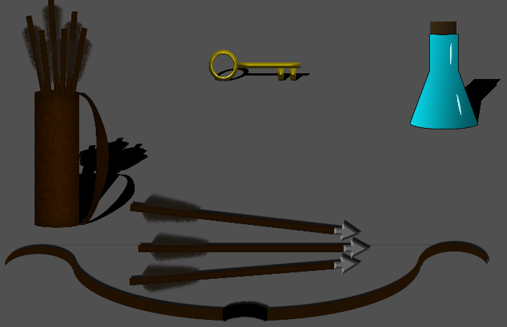

- Interactive Elements – The Ammo Pickups will be a brown leather quiver with arrows in it. It will spawn somewhere in the large dungeon room when the player runs out of arrows. The Health Pickup will be a blue potion in a glass vile. It will spawn somewhere in the large dungeon room when the player is low on health. The In-Game Pickup will be the keys. These will look like a golden skeleton key. The last key will be a grungy brown/gold color and be slightly larger than the rest. These will be inside of the chests.

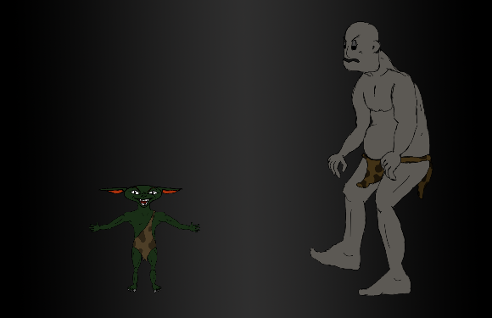

The Attacking Enemies with A.I. will be the goblins. These will be smaller than the player. They will be reptilian in nature. Small green retiles with large pointed ears. They will have a loin cloth as their only source of clothing. They will follow the player and attack them when close enough. This will happen when they become active at their spawn points. The Attacking Turret with A.I. will be the trolls. They will look for the player and throw rocks at them if they get within a certain distance from them. They will also follow the player, but the troll will stop a short distance away from the player and proceed to throw rocks. The troll will look like a large human-like beast with a dull visage resembling a rock with eye sockets. They will also have a large belly and bouldering shoulders. They will have a loin cloth as clothing as well, but they will have a torn tank top on their torso.

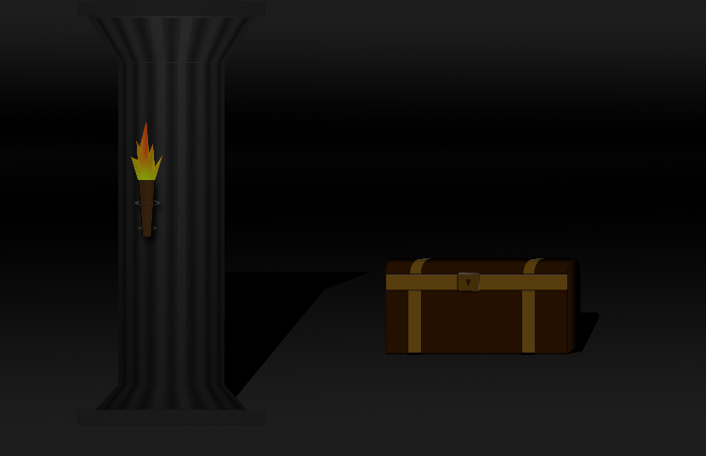

- Walkthrough – You will start at the dungeon entrance in the front of the room. From here there will be a chest in the center of the room that you must go to and open. Inside you will find a key that you must pick up. Once you pick that key up five goblins will come out of the doors on the back wall in front of you. You must defeat each of them in order to proceed to the first room and unlock it. The first room is the first one to the left as you entered the dungeons. Inside you will find another chest and a door in the back of the room that is black. You cannot enter this door. Once you opened the door to the room, three goblins will come out of the door in the back of the room. Defeat each of these then open the chest. Once you open the chest and grab the key a troll will come out of the back door. Defeat him to move on. He will be able to throw rocks at you. You may want to let him follow you out into the larger room so you can have the advantage of range with your bow and arrows. Once you defeat him you will be able to go the front right room to repeat the process. Defeat the three goblins that spawn when you open the door. Open the chest and grab the key. Defeat the troll that spawns from the door in the back by leading him into the larger room. Once the troll is defeated you must go the back left room of the dungeon. There will be no goblins that spawn from the door in the back this time. Once you open the chest and take the key, two trolls will spawn from the back door. You will need to defeat them to move on to the next room. The room in the back right of the dungeon from the entrance will be the final door on your quest. This time when you open the door five goblins will spawn from the room in the back of the room. Once you defeat these goblins you will be able to open the chest and grab the key. This will spawn two more trolls that you must defeat. Once you defeat them retrieve the key from the chest. This last key will open the door on the far side of the dungeon. This will lead you deeper into the dungeons of Milan. That is the end of this level. You have completed one dungeon and must move on to the next one to complete your mission for the King. Unfortunately, that is the extent of this level though so you are finished. You have won!

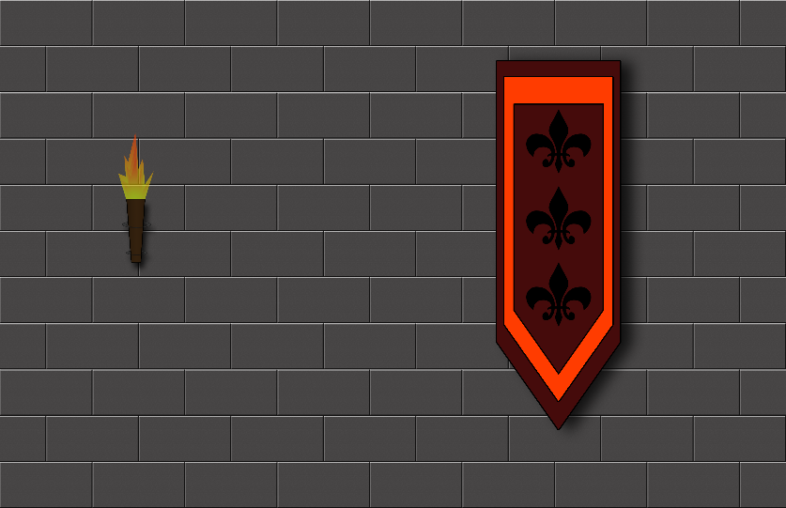

- Win and Lose Condition – The Win Condition is when the player extracts each key from all four chests as well as the main dungeon room's key. The player must defeat all 16 goblins and 6 trolls to obtain the last key. The Lose Condition is when the player runs out of health. The player can lose health from the goblins attacking or the trolls' rocks hitting them.

